WILLAMETTE COVE UPLAND - COMMUNITY TALKING POINTS
TIPS for YOU to participate in DEQ’s 120-day Public Comment Period

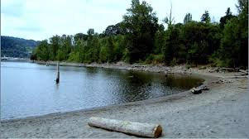

WHY IS THIS IMPORTANT TO ME? While people are in the throws with a pandemic, this large, centrally-located public property’s fate could get sealed if we don’t speak up now.

WHAT IS THIS? Now until the end of June 2020, OR DEQ are asking to hear community concerns, priorities and reactions to their proposed cleanup plan for this 27-acre toxic, North Portland site along the river. The community still has an opportunity to impact the cleanup of the Willamette Cove property because the plans have not yet been finalized. Below are PHCC’s community talking points reacting to DEQ’s proposed plan. Hopefully they can help you to craft your own recommendations. The Willamette Cove site is here: https://www.oregon.gov/deq/Programs/Pages/WillametteCove.aspx

*YOU CAN SUBMIT YOUR OWN COMMENTS by emailing WillCoveUpland@deq.state.or.us

FEEL FREE TO USE ANY OR ALL OF THESE TALKING POINTS, IF THEY ARE HELPFUL.

SUMMARY OF TALKING POINTS

DEQ should be pushing for a more robust cleanup option that includes preserving native trees and removal of as much unsafe soil as possible (5.2.3.2. Alternative 3b: Alternative Excavation and Offsite Disposal in the DEQ report). The agency’s preferred cleanup option that emphasizes consolidation and capping for cost savings, is unacceptable.
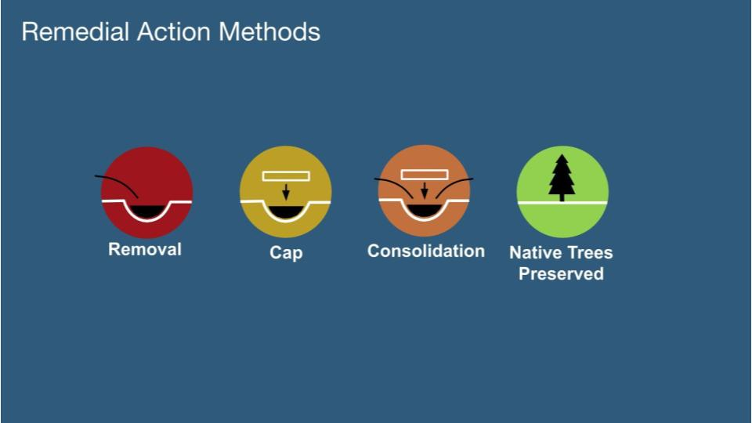
- CONSOLIDATION
Consolidation is not safe for human and ecological health in the long-term. We do not support any redistributed, permanent storage of toxic sediment on the site.
Page 2, No. 3 indicates that “...a preference will be given to offsite disposal of soil posing a higher risk to humans or animals/plants”. However, the DEQ plan calls to remove only 4,000 cubic yards of material for offsite disposal (Section 8.1), yet leave 23,000 cubic yards of soil with chemical concentrations exceeding human health limits on-site (Page 2, No. 2). This is about the same volume as 7 Olympic size swimming pools (see image below). Where is the preference for offsite disposal reflected? This plan appears to give preference to onsite containment.
- RISK FOR PEOPLE

The cancer exposure limit should be lower for houseless community members than for occasional recreational users, not the reverse. Houseless community members sleeping and staying at the site have direct exposure to cancer risk through touching contaminated soil, and accidentally ingesting as well as inhaling toxic dust, more so than recreational users.

The carcinogenic Risk-Based Concentration for total PCBs for recreational users is 0.74 mg/kg. The same Risk-Based concentration for houseless community members is 14 mg/kg. That is two orders of magnitude higher. It should be lower than .74 mg/kg

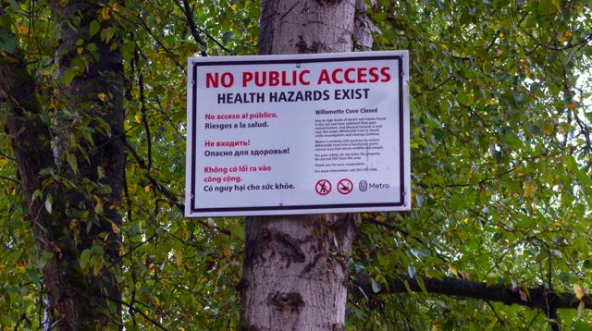

- INSTITUTIONAL CONTROLS

Institutional controls are unacceptable, because people and animals have accessed the full site since time immemorial, and will continue to do so, even if it is not currently the vision of Metro, the “property owner”, to have people access the river at Willamette Cove in the future.

The plan recommends a number of administrative controls including a 1. Contaminated Media Management Plan, 2. a Community and Outreach plan (page 2, No. 6), and 3. a deed restriction for the property (page 2, No. 7). These controls are often difficult to maintain in the long-term. For example, Contaminated Media Management Plans, which are put in place to notify anyone performing future work on a property about residual contamination, are difficult to maintain and enforce. Also, the cost estimate for the chosen remedy does not seem to include future costs associated with administrative controls. Finally, Willamette Cove is a community asset and any deed restrictions on the property should be formulated using input from the community that uses the property.

- FUTURE OVERSIGHT AND MONITORING

Collaborate with community stakeholders to set high standards for equitable implementation of future restoration, oversight and monitoring, every year.

The plan includes follow-up actions that will be required to maintain the Site, including maintenance of any engineered soil caps or covers and regular site monitoring (page 2, No. 6). This is an opportunity to advocate for inclusive procurement policies for follow-up work at the Site. On page 56 under Institutional Controls, the plan explains that DEQ will conduct periodic reviews “initially more frequent to 5-year reviews”. It is unclear what the initial review increment would be, but a 5-year review interval seems too long to ensure that the engineered controls are maintained appropriately. Additionally, the costs for long-term maintenance do not include DEQ review costs that are usually paid by responsible parties (or by taxpayers). These costs should be included in the cost estimates for long-term maintenance.

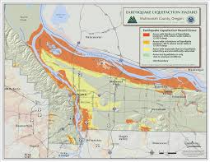

- WILLAMETTE COVE SEISMIC ACTIVITY & FLOOD SAFETY

Any engineered systems, such as soil caps or covers, used to contain contaminated materials at Willamette Cove must be designed to maintain protections for human and ecological health even in the event of potential seismic and climate-related events including earthquakes, river flooding, and fire. All capping used at the site should be designed to withstand the increased frequency and strength of severe weather events exacerbated by climate change referenced in the 2015 Multnomah County Climate Action Plan.

Section 2.2.4 indicates that Willamette Cove soils are comprised of fill, or added dirt, which can be unstable in seismic events. Because of the fill, we are concerned that the land will substantially move in the event of a major earthquake or increased flooding due to climate change (reference below). Although the DEQ plan mentions long-term seismic stability of the proposed soil cap, the cleanup plan must consider the seismic stability of any engineered remedial actions.

2015 Multnomah County Climate Action Plan: Page 24

“More intense rain events in the winter may have far reaching impacts locally. Potential economic, social and environmental impacts from flooding may include water damage to homes and businesses, as well as roads, railroad tracks, levees, bridges and culverts. In addition, more rain falling in the winter will continue to stress Portland’s systems for managing storm water runoff and urban flooding. Wetter winters may also increase the incidence of landslides, particularly following prolonged periods of precipitation when the soil is already saturated with water”

- BIOREMEDIATION

Because of community recommendations, the Port and Metro are about to conduct a 3- to 6-month Bench Test (trial run) to determine whether the use of fungus and plants/trees are viable options to remediate the mix of contaminants at Willamette Cove. If the initial test has favorable results, we support a full-scale application of the bioremediation method at the Willamette Cove site, and expect this method to be fully integrated into the final cleanup plan.

CONCLUSION

Like many cleanup plans before, this one leaves contamination in place, underestimates the long-term costs of maintenance, then uses the underestimated costs to demonstrate that the less-protective option is the most cost-effective. In the long-term, this cleanup would be less costly and more protective of human and ecological health if more robust remediation were conducted as soon as possible.

Overall, DEQ’s proposed cleanup plan may alleviate some of the risks posed to people and animals by the contamination at the property, however it is unacceptable because it leaves in place contamination at concentrations above human and ecological risk-based standards and will require “Long-term monitoring and maintenance in perpetuity... (Section 5.2.4.3, page 47)”.
While Table 20 in the staff report estimates the cost of long-term monitoring for this option, it does so only for a period of 30 years with conservative assumptions. 30 years is a long time, but is not the same as forever, or in perpetuity.

